1. 
2. We will use DSL query approach as it exposes all the features of elasticsearch.
3. But we will also see request URI (query string) approach as we may want to hack away in terminal.
4. To get all documents from an index  
   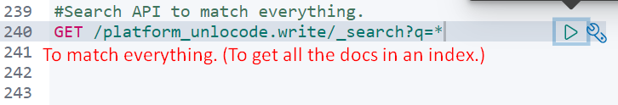
5. Matching content from Array: NOTE: This process is same as above. Elasticsearch is smart enough to understand even though it’s an array. 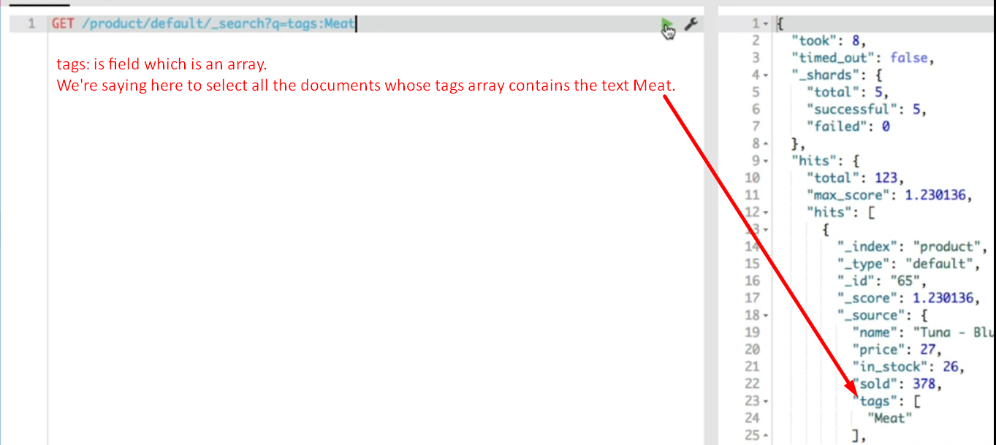
6. How to use Boolean logic within the search query 🡺 Using AND, OR   
     
   NOTE: if you use cURL, you need to replace space with %20 otherwise query will fail. (Meat%20AND%20name:Tuna)